.....................................................................................................................................................................

Shipping Normal Workflow WH Test Scenario

……………………………………………………………………………………………………………………………………………………………………

WMS Application [Solid]

- Note: - Containers should be at particular location before performing a shipping cycle.

- Select the Logical Gate.

Note: Number of Gate reserved should be same as number of Trucks.

  - Go to Menu Configuration
Configuration > Logical Gates > Enter Display button
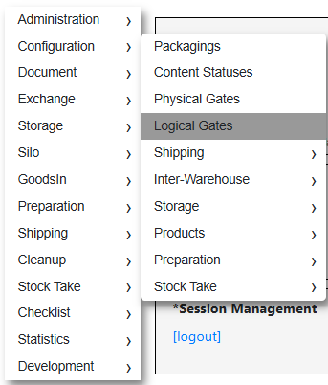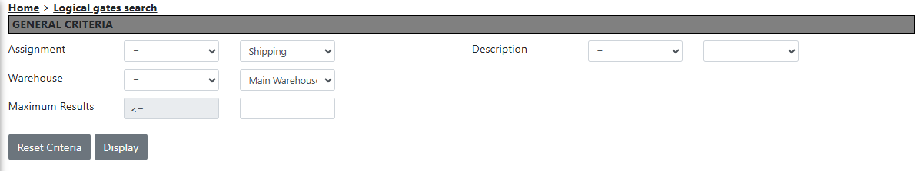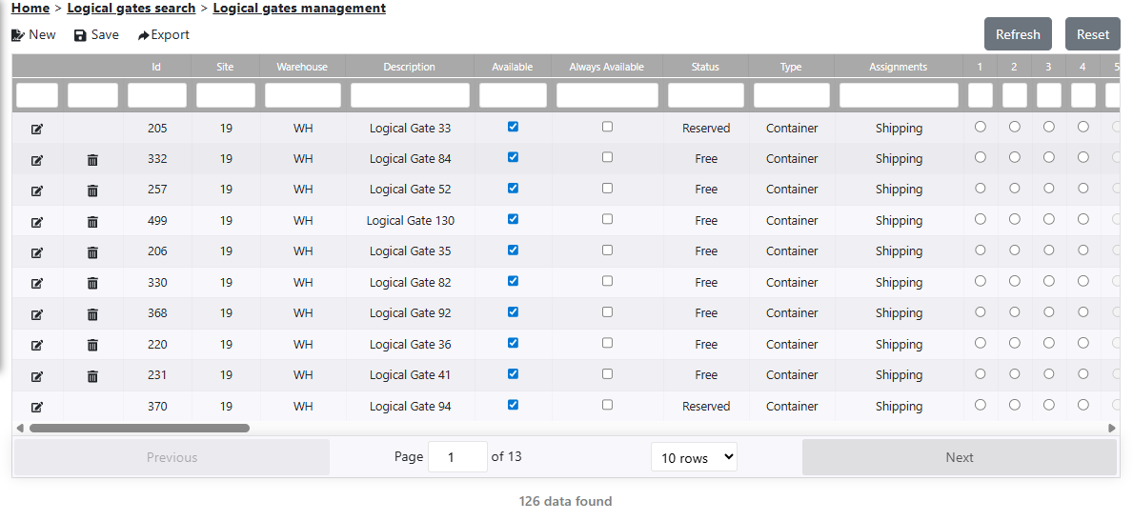
  - Select the Gates and Click on Save button.

- Check preparation order status (Launchable)
  - Go to Menu Location
Preparation > Order > Enter PO Number > Display
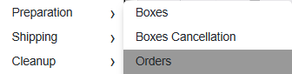
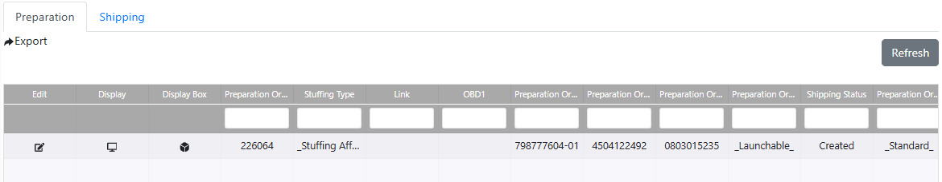

  - Select and note product and batch It will show the details of particular preparation order, Like(batch, product etc)
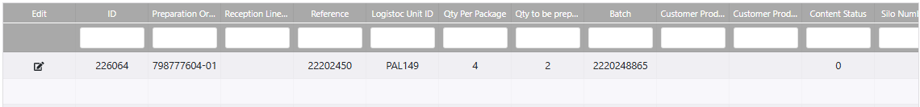

- Check Availability of Stock.

  - Go to Menu Location
Storage > Management > Stock by batch > Enter batch > display
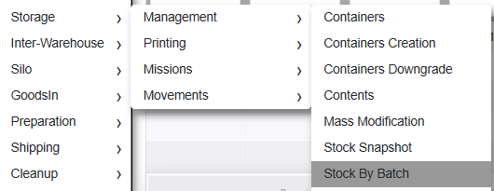
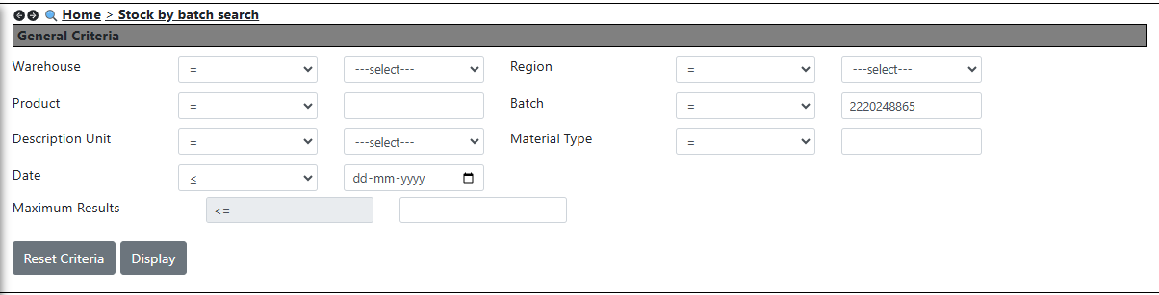

  - If Stock Available and not in Overflow location then proceed ahead with that PO

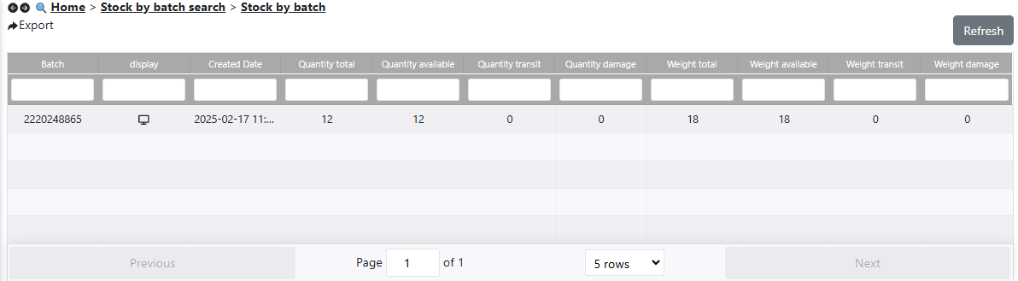

- Create New wave and Launch

  - Go to Menu Location
Preparation > Waves > Display > new > Create and select
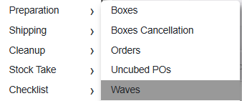
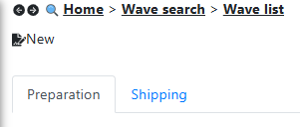
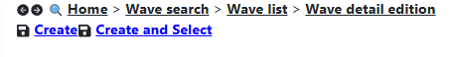
  - Click on add line (plus sign)
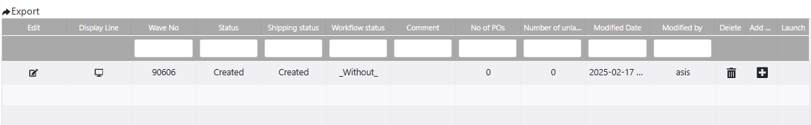
  - Put preparation order and Display
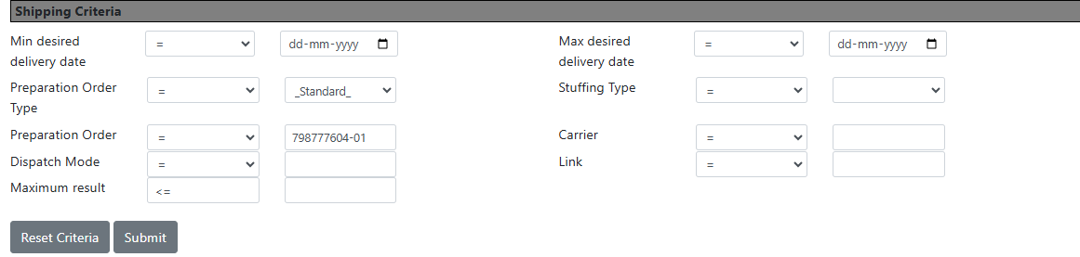

  - Add (plus sign) >> for adding preparation order
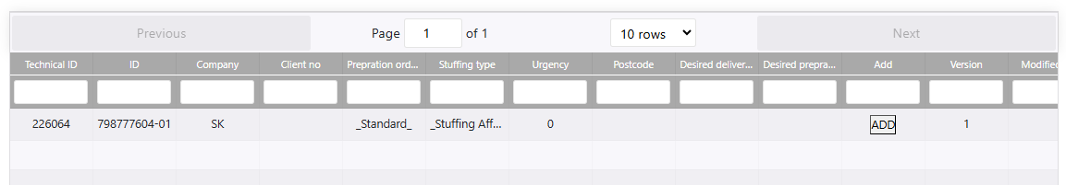

  - Click on Back, and then click on Tick sign.
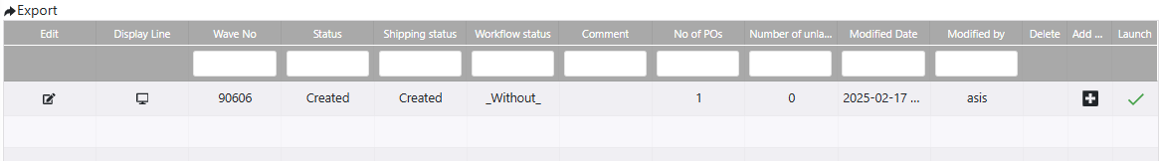

  - Click on WH.
Fill (Select the logical gate which you have selected in Logical gates Manu in a dropdown). Then click on OK button.
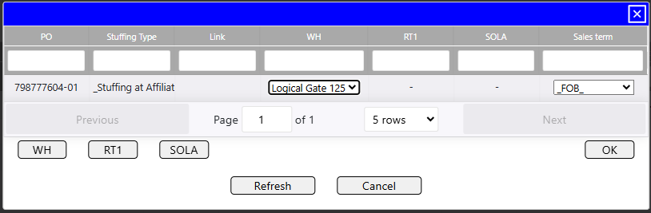

- Check the status of preparation order
  - Go to Menu Location
Preparation > Order
  - Enter your preparation order no > Display Status of the PO should be Launched

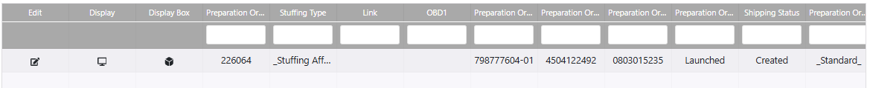

- Distribution of mission
  - Go to Menu Location
Storage > Mission > Display > Master mission
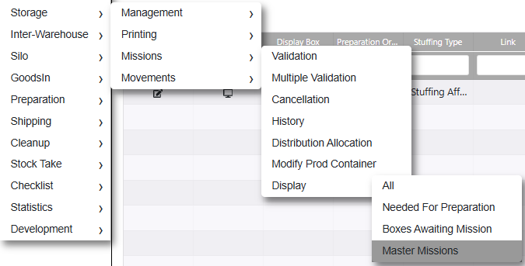
  - Enter preparation order ID and Display. It will Show Mission No, Mission ID, Origin, Destination, status etc
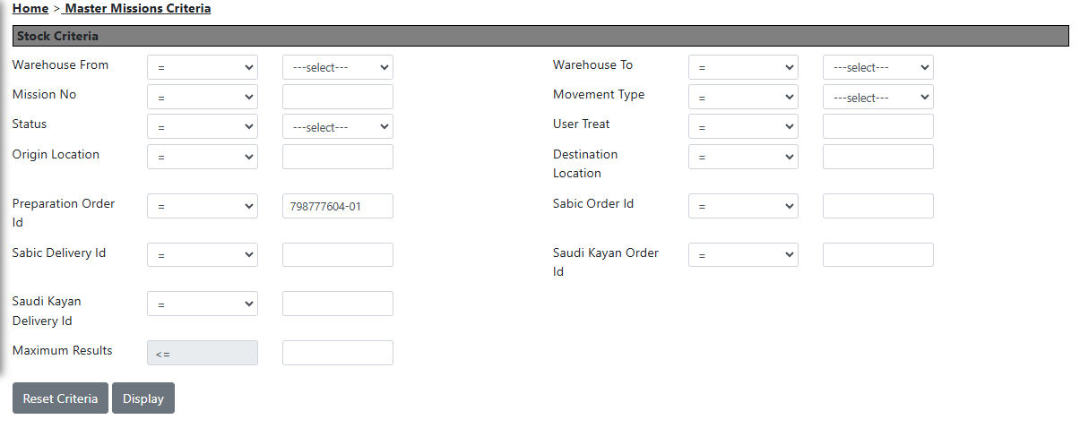
  - Select row and fill Distributed to (select dropdown) and click on Modification
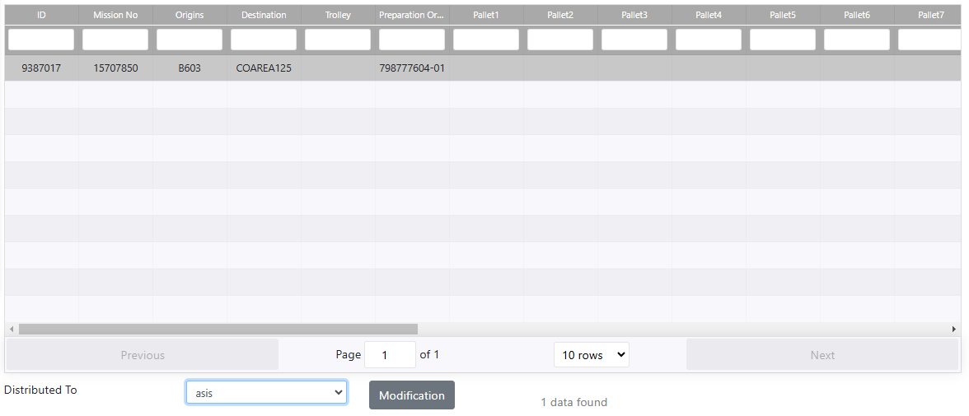

- Check mission distribution on Radio Terminal

  - Go to Menu Location
Mission > Mission Distribution
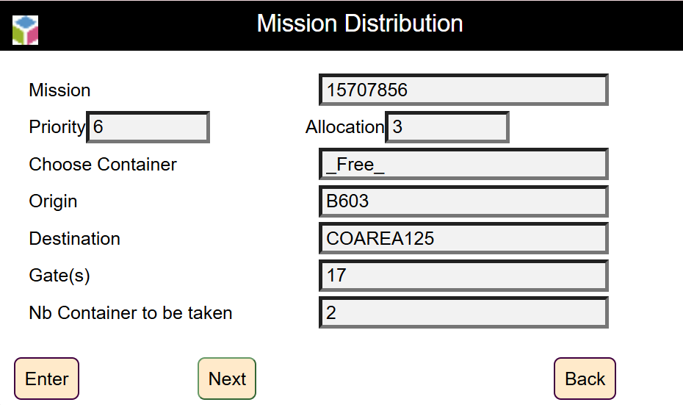
  - Check your Mission and click Enter.
  - Copy the location as same and click on Enter.
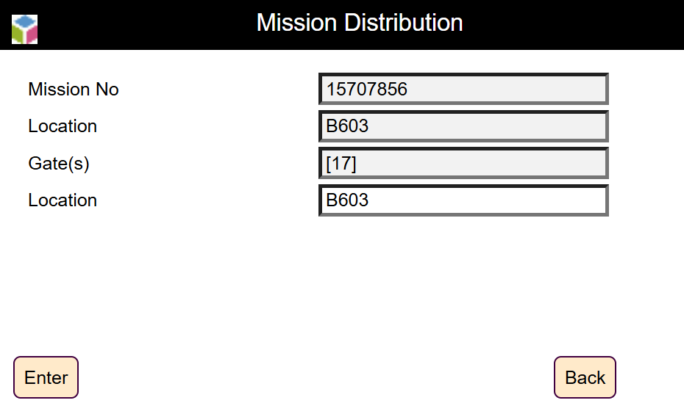
  - Enter trolley no. 039999905833388709 and click on Enter.
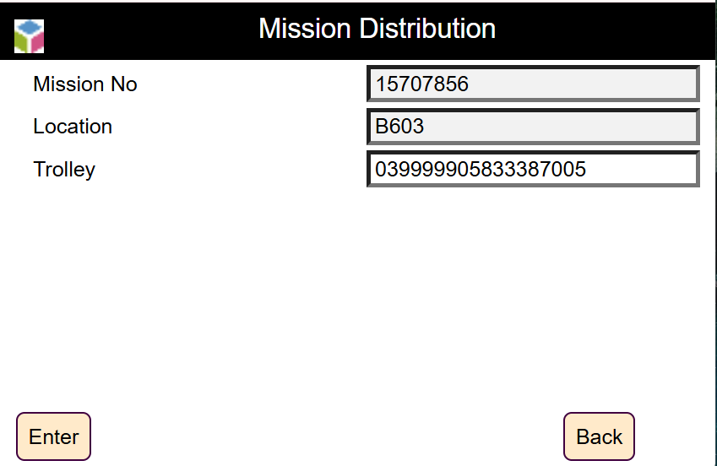

  - Now we have to enter Container no
    - Which we will get from (Storage > Management > Contents) (WMS application)
    - Fill the Location, Product, Batch and click on display. (WMS application)"
  - Now put the required container one by one and at last click on end.
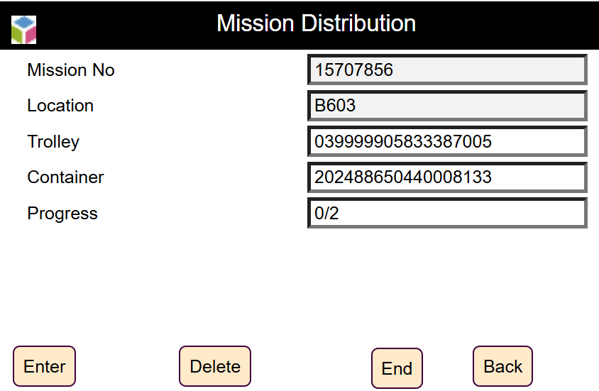
  - Click on END after loading all your Containers.

- Unloading Trolley
  - Click on unload trolley.
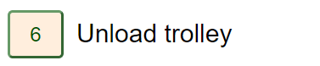
  - Enter trolley no. And click on enter
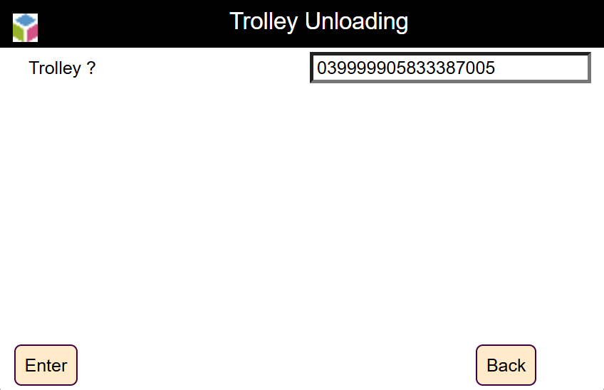
  - Fill the Location and click enter.
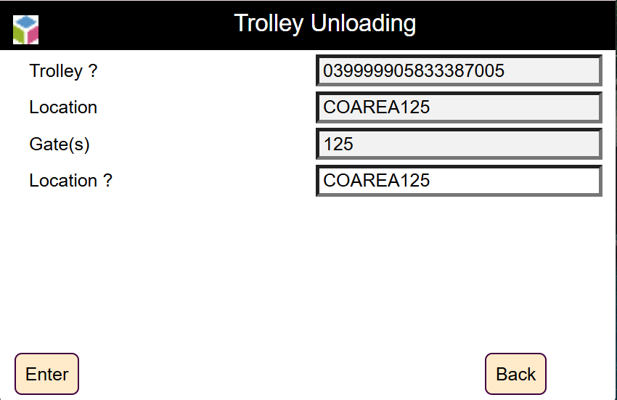
  - Now enter container no. Which was used at the time of loading of trolley one by one.
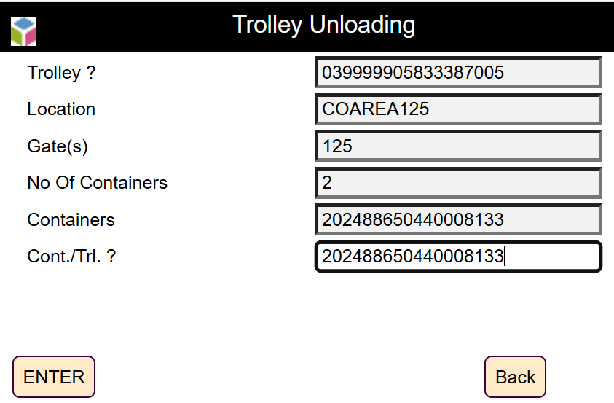
  - When the entire containers unload and Click on Back.

- Check the status of wave
  - Go to Menu Location
  - Preparation > Wave
  - Fill wave no and click Display and check the status it should be “InPreparation”

- Check the status of preparation order
  - Go to Menu Location
Preparation > order > Enter your PO > Display
  - It should be in “InPreparation”
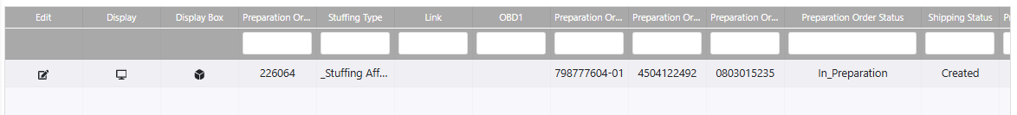

- Trailer association
Note : Number of Gate reserved should be same as number of Trucks.
  - Go to Menu Location
Preparation > Trailer association
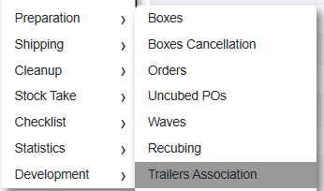
  - Fill the Preparation order and click Display
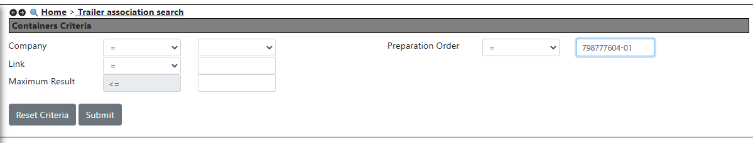

  - Now click on edit and enter the following values and Click on Save
    - Driver name
    - Trailer identification
    - RFID tag
    - Click on Save button
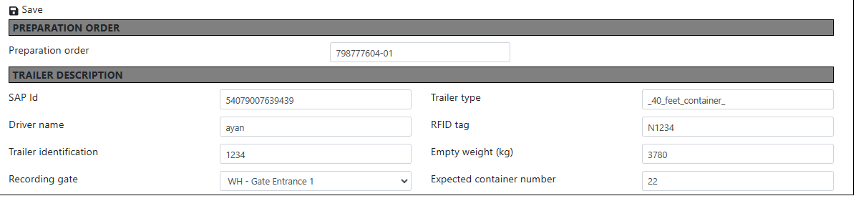
  - One row will be created or show and match all data as per your entry.

- Trailer Gate Association
  - Go to Menu Location
  - Preparation > Trailer association
  - Check the status as “gate allocated” and recording gate as “gate shipping” any gate no. Automatically updated (ex gate shipping 5)

- Shipment through Radio Terminal
  - Click on shipping menu and Select Trailer/Gate allocation.
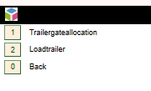
  - Enter “RFID tag/trailer” and click Enter It will show as have you inspected the trailer.
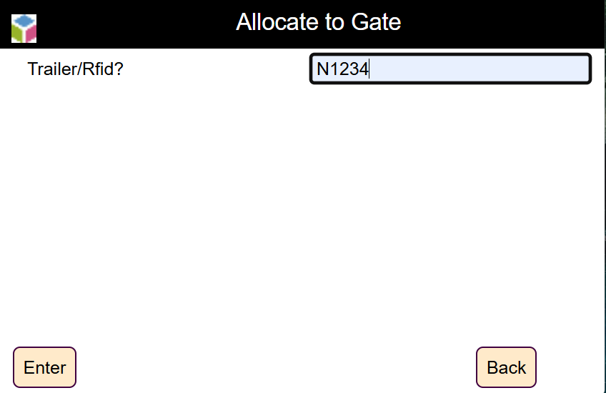
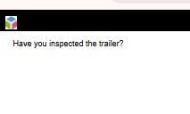
  - Enter gate (where ‘D’ is code and the gate no)
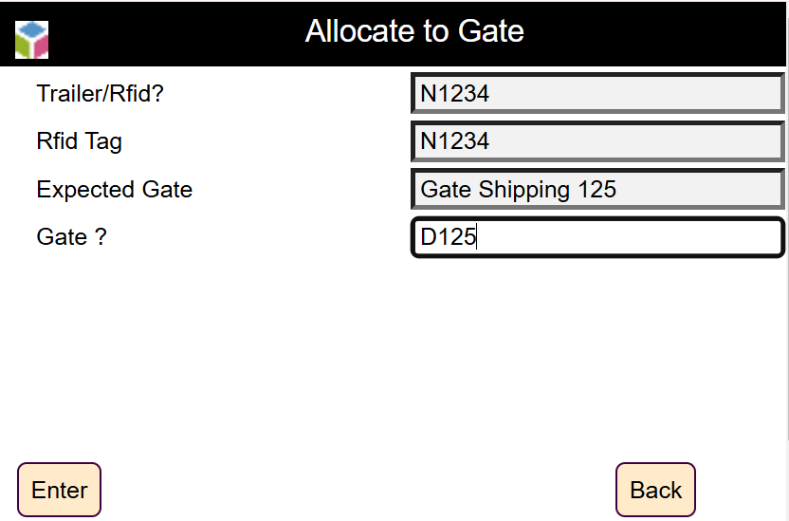

  - Click on Enter
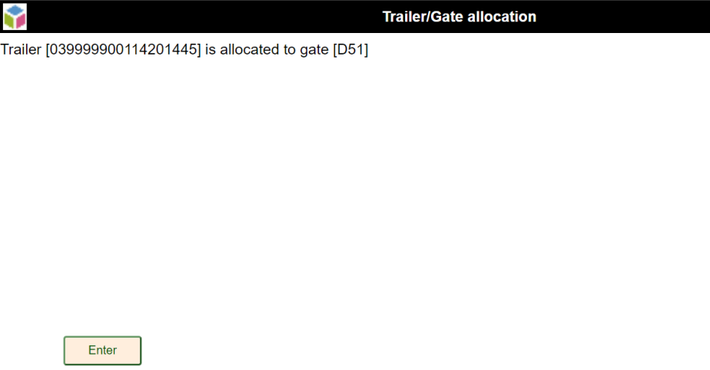

- Trailer Loading
  - Click on Shipping and select load trailer.
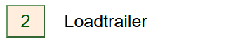
  - Enter trailer/barcode and check on enter.
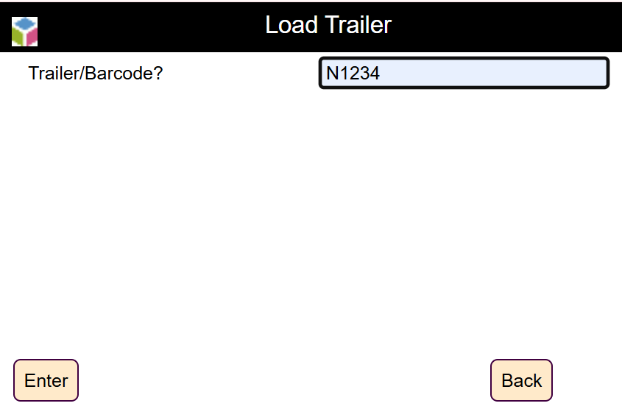
  - Enter the container no and click on enter.
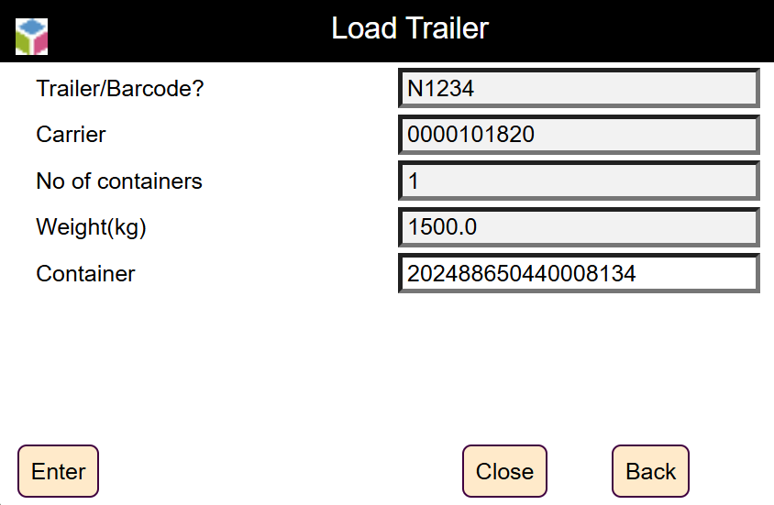
  - Click on close button.
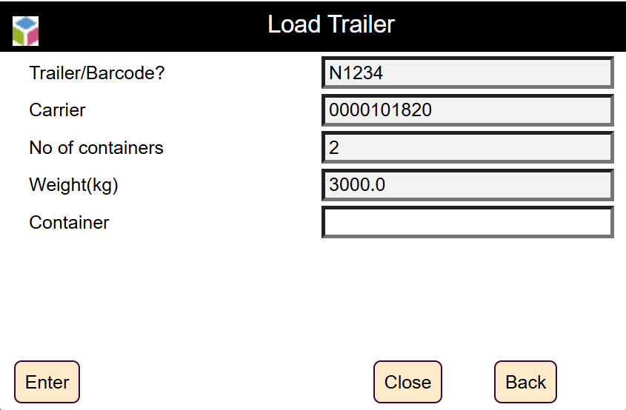
  - Now go to boxes screen in (WMS-application) (Preparation > Order > Box).
  - Check the shipping status as palletized.
  - In the same way scan the entire container one by one and click Close and then click Valid on below screen.
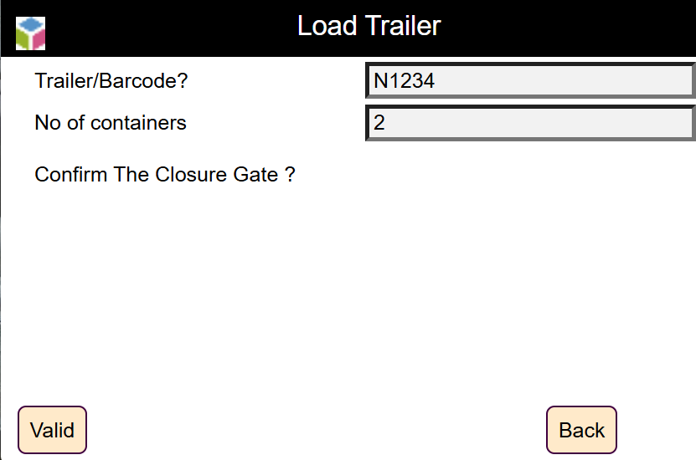

  - Enter trailer identification and click on Enter.
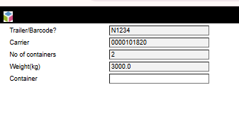
  - Enter seal and click on valid on below screen. Trailer is now successfully loaded.

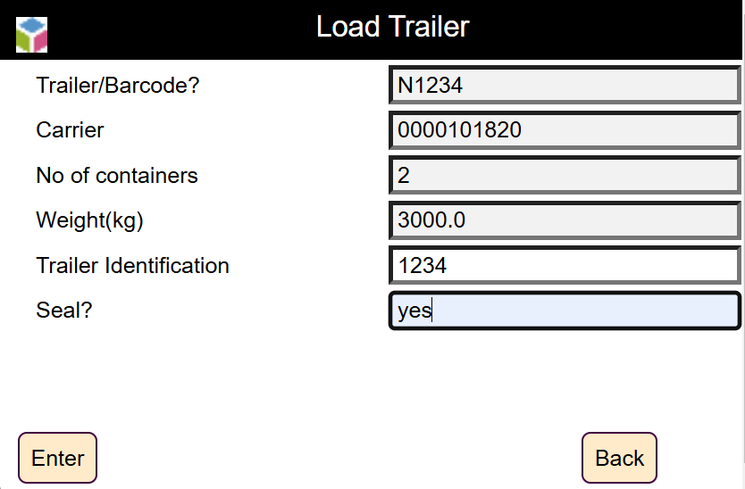

- Trailer Release
  - Go to Menu Location
Shipping > Trailer release
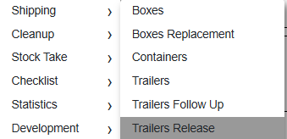
  - Fill RFID tag and click on Display
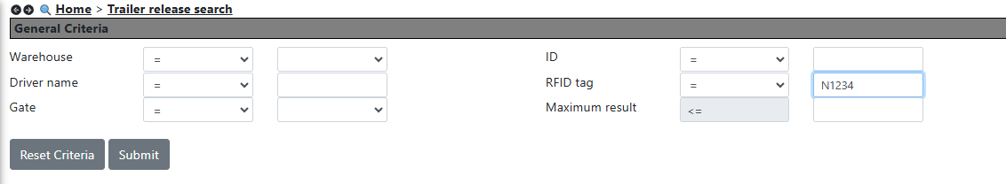
  - Select row and click Release.
  - Selected row will not be visible after click on release.
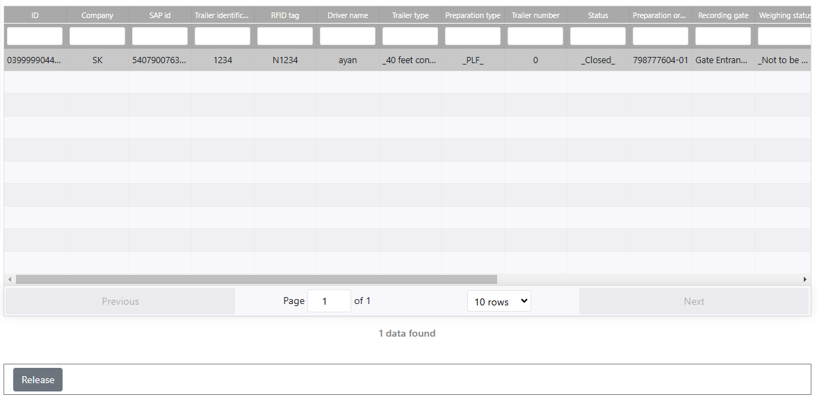

- Trailer Exit
  - Go to Menu Location
Shipping > Trailer
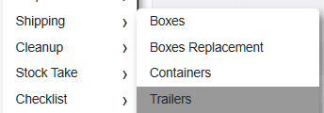
  - Fill RFID tag and click on Display
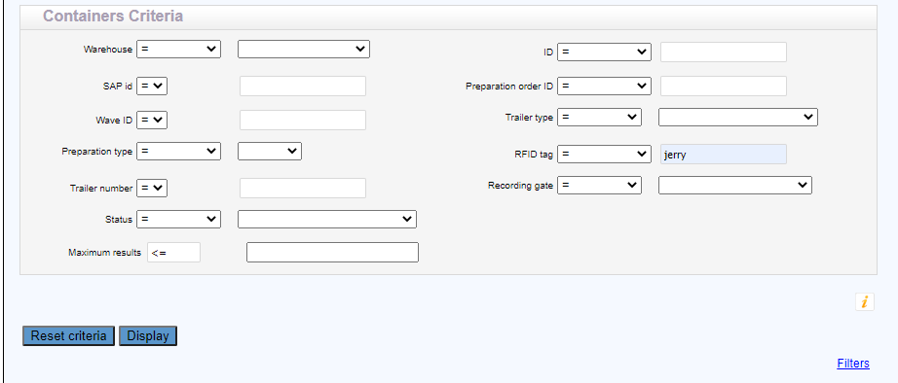
  - Then scroll right and select trailer icon and click (Trailer exit)
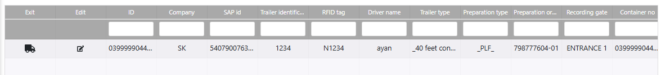

- Check Final Statuses
  - Go to Menu Location
Preparation > Order
    - Shipping status: palletized / shipping to be confirmed
    - Preparation status: prepared
    - Stuffing type: stuffing at PLF

  - Go to Menu Location
Preparation > Wave
    - Shipping status: palletized / shipping to be confirmed
  - Go to Menu Location
Storage > Management > Containers
    - Enter Batch number

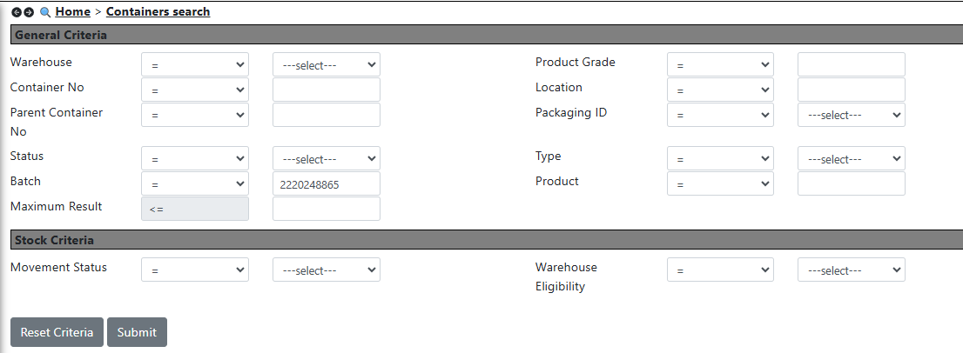
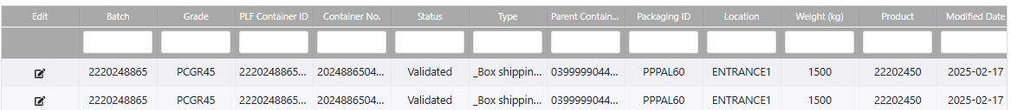
  - Now we can see that the location status of containers is on ENTRANCE1. It means the trailer is exited successfully.

This page is intentionally left blank

